- :: About us ::-


Acme Infosolutions started its journey in the year 2000 in the name & style of Acme Infotech, a modest start-up focused primarily in providing maintenance support for computer hardware. The outfit started with a meager capital investment of Rs. 5,000 and a headcount of two, comprising the business partners themselves, and was located in a rented space barely 25 square feet in area. The turnover started with Rs. 57,000 in the first year of operations, and the venture broke even in the very first year of its existence.

As the years went by, the outfit expanded into uncharted territory and soon started providing turnkey solutions to both retail and corporate clients covering the entire spectrum of the digital universe. In order to capture the rapidly expanding portfolio of products & services, the firm was rechristened as
Acme Infosolutions in 2009. Today, it would only be fair to say that we have gained unmatched experience in providing solutions pertaining to a plethora of business and technical domains, specializing in serving a wide network of corporate (comprising primarily small & mid-sized companies) as well as retail clients. Commensurate with the same, our turnover for the nine month period ending 31st December, 2011 exceeded Rs. 30 lakh and it would be realistic to expect it to cross the Rs. 40 lakh mark for the full year.

- :: Our Operations :: -

We work on multifunctional information systems, related to creation of state-of-the-art information platforms according to our customer’s needs. We bring innovative ideas and cutting-edge technologies into the business of our customers. We take full advantage of the constantly evolving world of technology and leverage our expertise to bring the digital world to work wonders for you, i.e. our clients.

Today, while providing turnkey solutions comprising both sales and service to our customers, we bank on our technocrats equipped with years of experience in building digital infrastructure with particular emphasis in ensuring that our products and services are not only clean & aesthetic, but also meet the most stringent of quality standards. Our enterprise now comprises more than twenty technocrats who constantly strive to achieve our following objectives:

- To develop our own web based products & tools to maintain, host, license, sell, distribute, import, export or promote through electronic & print media, internet marketing, e-mail marketing, web promotions, data mining, data processing.

- To carry on the business of outsourcing software development, customized software development, maintenance of software systems, software for vertical markets like maritime solutions, transportation and logistics, insurance, securities market, finance, health care, dot com companies, B2B, B2C, BPO & LPO web enabled tools.

-  To carry on the business of providing solutions pertaining to sale of branded as well as assembled computers of all makes, kinds & configurations including computer accessories, repair as well as maintenance of computing systems, networking solutions, computer programming, business end-to-end computing solutions, electronic data processing and computer hardware.

- :: Our clientele :: -

Our clientele today comprises a wide variety of small & mid-tier companies as well as eminent retail persona. For example, we have been engaged in providing services to West Bengal Tourism Development Corporation Ltd. (WBTDC), a premier travel & tourism company wholly owned by the Government of West Bengal for several years now as a preferred vendor in relation to its digital infrastructure. Other prominent names featuring in our clientele include

- West Bengal Tourism Centre Kolkata
- Mangaldhara Tourism Property, WBTDCL
- Kalighat Pilgrimage Facilitation Centre, WBTDCL
- RM Clinical Lab
- Jaico Publishing House
- Handy Infrastructure Pvt. Ltd.
- Quatron Control Systems Pvt. Ltd.
- Amit Projects and Controls
- Forward
- Bake Club
- Lekhapara
- Barisha Girls High School
- Adroit Electronics Accessories P. Ltd.
- Amulya Jyoti Eye Foundation
- Arvind Limited (Telecom Division)
- Atop Electronics Corporation
- Duro Polyprene Ltd.
- Jivaka Diagonostic & Healthcare
- Pioneer Diagnostics & Polyclinic Pvt. Ltd.
- Standard Tours & Travels
- Sunflower Montessori School & Day Care
- and MANY MORE

In addition, we have also been providing services to a host of retail customers.

- :: Our infrastructure :: -
Barely into our second year of operations, the firm today is located at a plush 250 square feet space at 167, Santosh Roy Road, Kolkata – 700 008 . Our Manpower comprises more than 20 engineer’s well versed in technical domain under our Service Head Mr. Shovan Sahu. We are also recently operating in the retail format under The Brand Name of SP INTELLIWARE. Our Fist Store Started operation on December 2011 in South Kolkata. Our Company hierarchy is as follows:

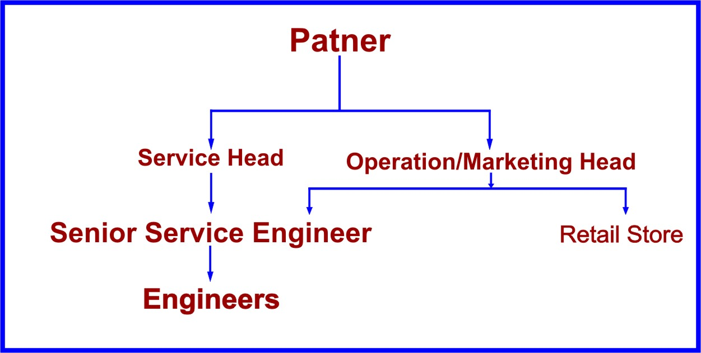

Anyone wanting to get in touch with us can mail us their queries at acmeinfosolution@gmail.com. / acmeinfosolution.software@gmail.com

